How does this affect me?
- Your 2019 Health Care FSA and Dependent Care FSA Plans originally had a filing deadline of March 31, 2020. Due to the COVID-19 outbreak, the IRS is now requiring filing deadlines to be extended through the end of the National Emergency Period. Because the end date of this period continues to be unknown, we have temporarily extended our filing deadline to December 31, 2020.

How do I submit my FSA claims?
- My SmartCare Portal: https://www.mywealthcareonline.com/bccsmartcare/
- My SmartCare App (free in iOS and Android app stores)
- E-mail: FSA-Claims@BCCBenefitSolutions.com
- Fax: 412-276-7185
- Mail: BCC, Attn: Claims
Two Robinson Plaza, Ste. 200
Pittsburgh, PA 15205

How do I register for My SmartCare?
You can register from online portal or mobile app using the following information:
- Use your Social Security Number as your Employee ID
- Use your Benefits Debit Card number or your Employer ID as your Registration ID

Questions?
Contact BCC’s Customer Service Center:
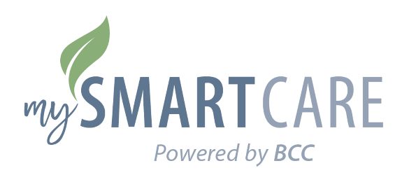
- 800-685-6100
- CustomerSupport@BenXcel.com

